**SW2 – Project Evaluation Form**

* **Each team must submit the following Documentation that contains:**

**- Project Description in detail.**

**- Class Diagram. And Database Schema.**

* **Each team must submit the project via GitHub:**
* **Source Code.**
* **Video Demo for running ( 2 – 5 Minutes ).**
* **Documentation and Evaluation Form**
* **The Evaluation will start with giving all teams 30 marks then check the following criteria:**

|  |  |  |  |  |  |  |  |
| --- | --- | --- | --- | --- | --- | --- | --- |
| **Violation Level** | | | | **Full** | **Medium** | **Small** | **Grade** |
| **Documentation** | | | | **-5** | **-2** | **-1** |  |
| **Not Apply MVC (it does not Separate Business logic from GUI).**  **Example of violation: write the implantation for a method such as an inset item into the database inside the Button Action method)** | | | | **-6** | **- 3** | **-1** |  |
| **Violate clean code – Variables** | | | | **-2** | **-1** | **-.05** |  |
| **Violate clean code – Functions** | | | | **-2** | **-1** | **-.05** |  |
| **Violate Single-responsibility Principle** | | | | **-2** | **-1** | **-.05** |  |
| **Violate Open-closed Principle** | | | | **-2** | **-1** | **-.05** |  |
| **Violate the Liskov Substitution Principle** | | | | **-2** | **-1** | **-.05** |  |
| **Violate Interface Segregation Principle** | | | | **-2** | **-1** | **-.05** |  |
| **Violate Dependency Inversion Principle** | | | | **-2** | **-1** | **-.05** |  |
| **Not Upload code to GitHub** | | | | **-1** | | |  |
| **Only One Branch Without Merge (GitHub)** | | | | **-2** | | |  |
| **Only One Contribution (GitHub)** | | | | **-2** | | |  |
| **Total Minus from Grade** | | | |  |  |  |  |
| **Design Pattern Bounce** | **+4** |  |
| **Bounce on Overall Work** | **+2** |  |
| **Total Team Grade / 30** |  | |

|  |  |  |  |  |
| --- | --- | --- | --- | --- |
| **Name (Arabic)** | **ID** | **Individual Bounce +2** | **Grade** | **Grade** |
| هاجر محمد عبدالله محمد | 201900922 |  |  |  |
| مصطفى عبدالناصر عبدالفتاح عيسى | 201900823 |  |  |  |
| نادر إبراهيم حموده عبد الكريم | 201900886 |  |  |  |
| مؤمن عماد الدين عبد الفتاح عبد الغفار | 201900863 |  |  |  |
| شمس طه عبد العزيز القاض | 201900373 |  |  |  |
|  |  |  |  |  |

**Class diagram**

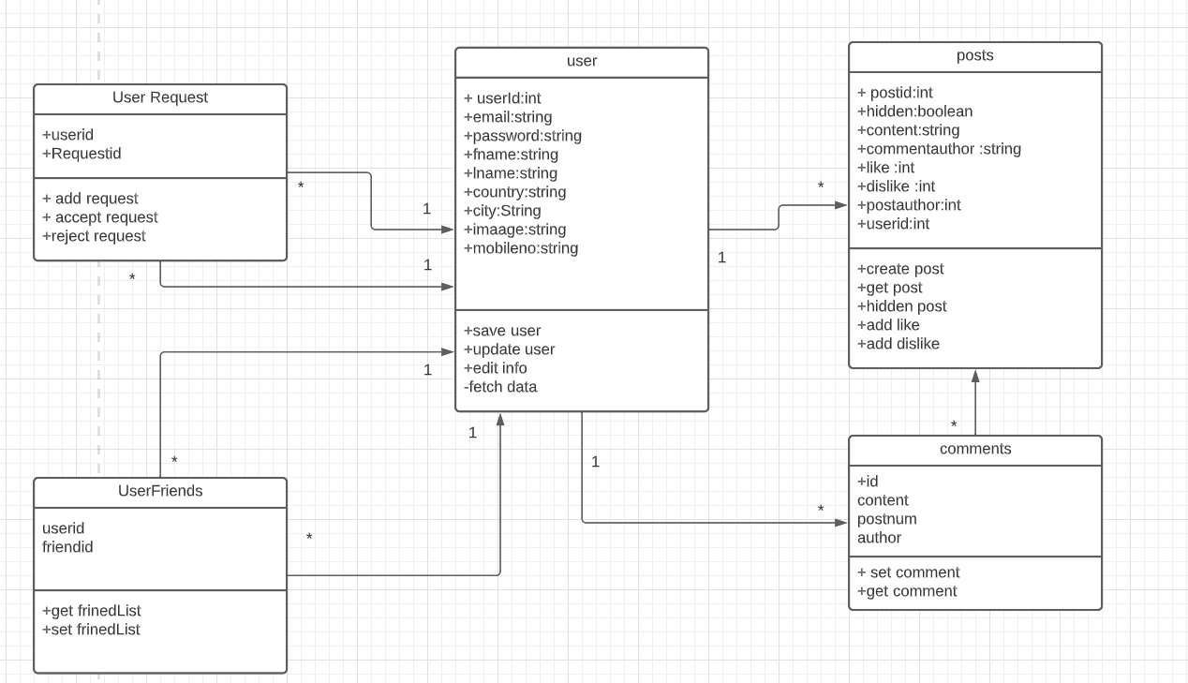

**Database Schema**

